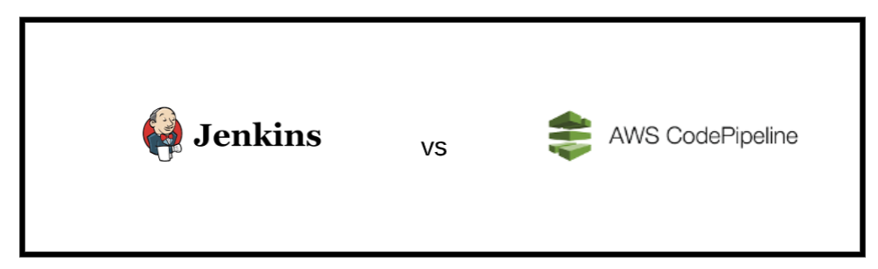

Jenkins Pipeline is a set of plugins which support implementing and integrating continuous delivery pipelines into Jenkins. A JenkinsFile is required to make sure that jenkins can handle the deployment of the app to the pipeline. The pipeline code describes the build process which includes stages for building an application, testing it and then delivering it.

AWS CodePipeline is a managed CI/CD tool that provides integrated Amazon cloud DevOps tooling. CodePipeline is actually a suite of services. It combines CodeBuild, CodeDeploy and Git-based source code repository CodeCommit. CodePipeline is very similar to the jenkins pipeline as it automates the build, test, and deploy phases of your release process every time there is a code change

Both pipelines oversee the CI/CD part of the deployment the two are very similar however we have chosen to use jenkins due to personal preference and also due to the benefits of using a jenkins file.

Jenkinsfile benefits include:

* Code review/iteration on the Pipeline
* Audit trail for the Pipeline